**Homework on literature search & reference management**

(Hand in on Nov. 13, 2018 before class)

**1. Please list five or more of the frequently-used databases related to your majors.**

1. Chinese Science Citation Database，CSCD)，
2. Web of Science (SCIE, SSCI, A&HCI, ISI Proceedings)，
3. EBSCO，
4. Foundations and Trends® Technology eBooks Library，
5. IEEE/IET Electronic Library

**2. Firstly, search literature on the area that you are interested in (e.g., “arithmetic for computers”, “fine blanking”, etc.) through the library database** [**Web of Science**](http://www.lib.sjtu.edu.cn/index.php?m=content&c=index&a=show&catid=223&id=224)**. Then do the following exercises:**

**(1****) Install the reference manager** **EndNote in your laptop (You can download the** **trial version via** <http://endnote.com/downloads/30-day-trial>**) or other reference manager (such as NoteExpress** <http://www.lib.sjtu.edu.cn/index.php?m=content&c=index&a=show&catid=223&id=234>)**. Then, save the complete bibliographic records of two or more articles that you are interested in, including the abstracts, to EndNote desktop or other reference manager.**



**(2) Analyze the records searched through** [Web of Science](http://www.lib.sjtu.edu.cn/index.php?m=content&c=index&a=show&catid=223&id=224)**, and answer the following questions:**

1) How about the publication year distribution of the searched records?

 It’s most concerned at 2016 and 2017.

2) Who writes the most articles?

 FOJIMOTO, a Japanese writes the most articles.

3) Whose articles are the most concerned? (highly cited papers, frequently-used articles, etc.)

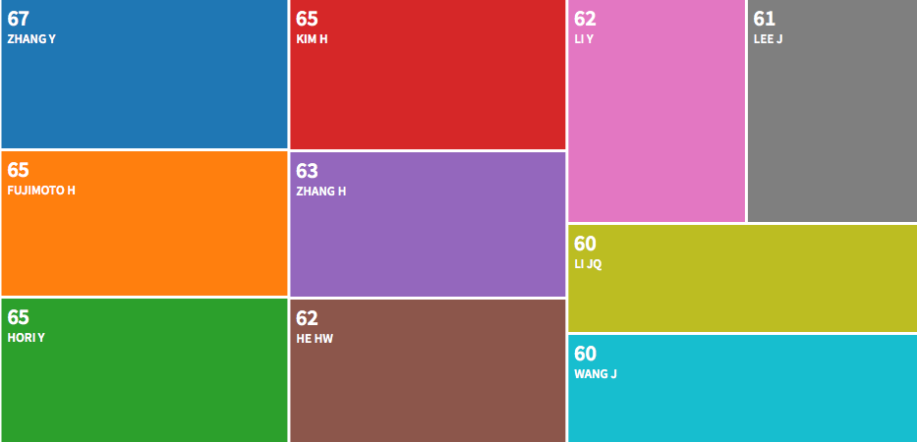

Zhang Y’s articles are the most concerned.

**Notes:**

1. Use key words in the literature search, e.g., “cloud computing”. Besides, try to use different forms, representative synonyms and near-synonyms of the key words, e.g., different forms and synonyms of “electric vehicle*” can be “electric car*”, EV, etc.

2. When you want to access the databases off campus, we suggest you try the Proxy Service or VPN Service: <http://net.sjtu.edu.cn/wlfw/xywdl.htm>.

3. If you run into difficulties, please do not hesitate to email the library mechanical engineering subject service team by [qlhuang@lib.sjtu.edu.cn](mailto:qlhuang@lib.sjtu.edu.cn), [xgao@lib.sjtu.edu.cn](mailto:xgao@lib.sjtu.edu.cn), [zlchen@lib.sjtu.edu.cn](mailto:zlchen@lib.sjtu.edu.cn) or [ywang@lib.sjtu.edu.cn](mailto:ywang@lib.sjtu.edu.cn).